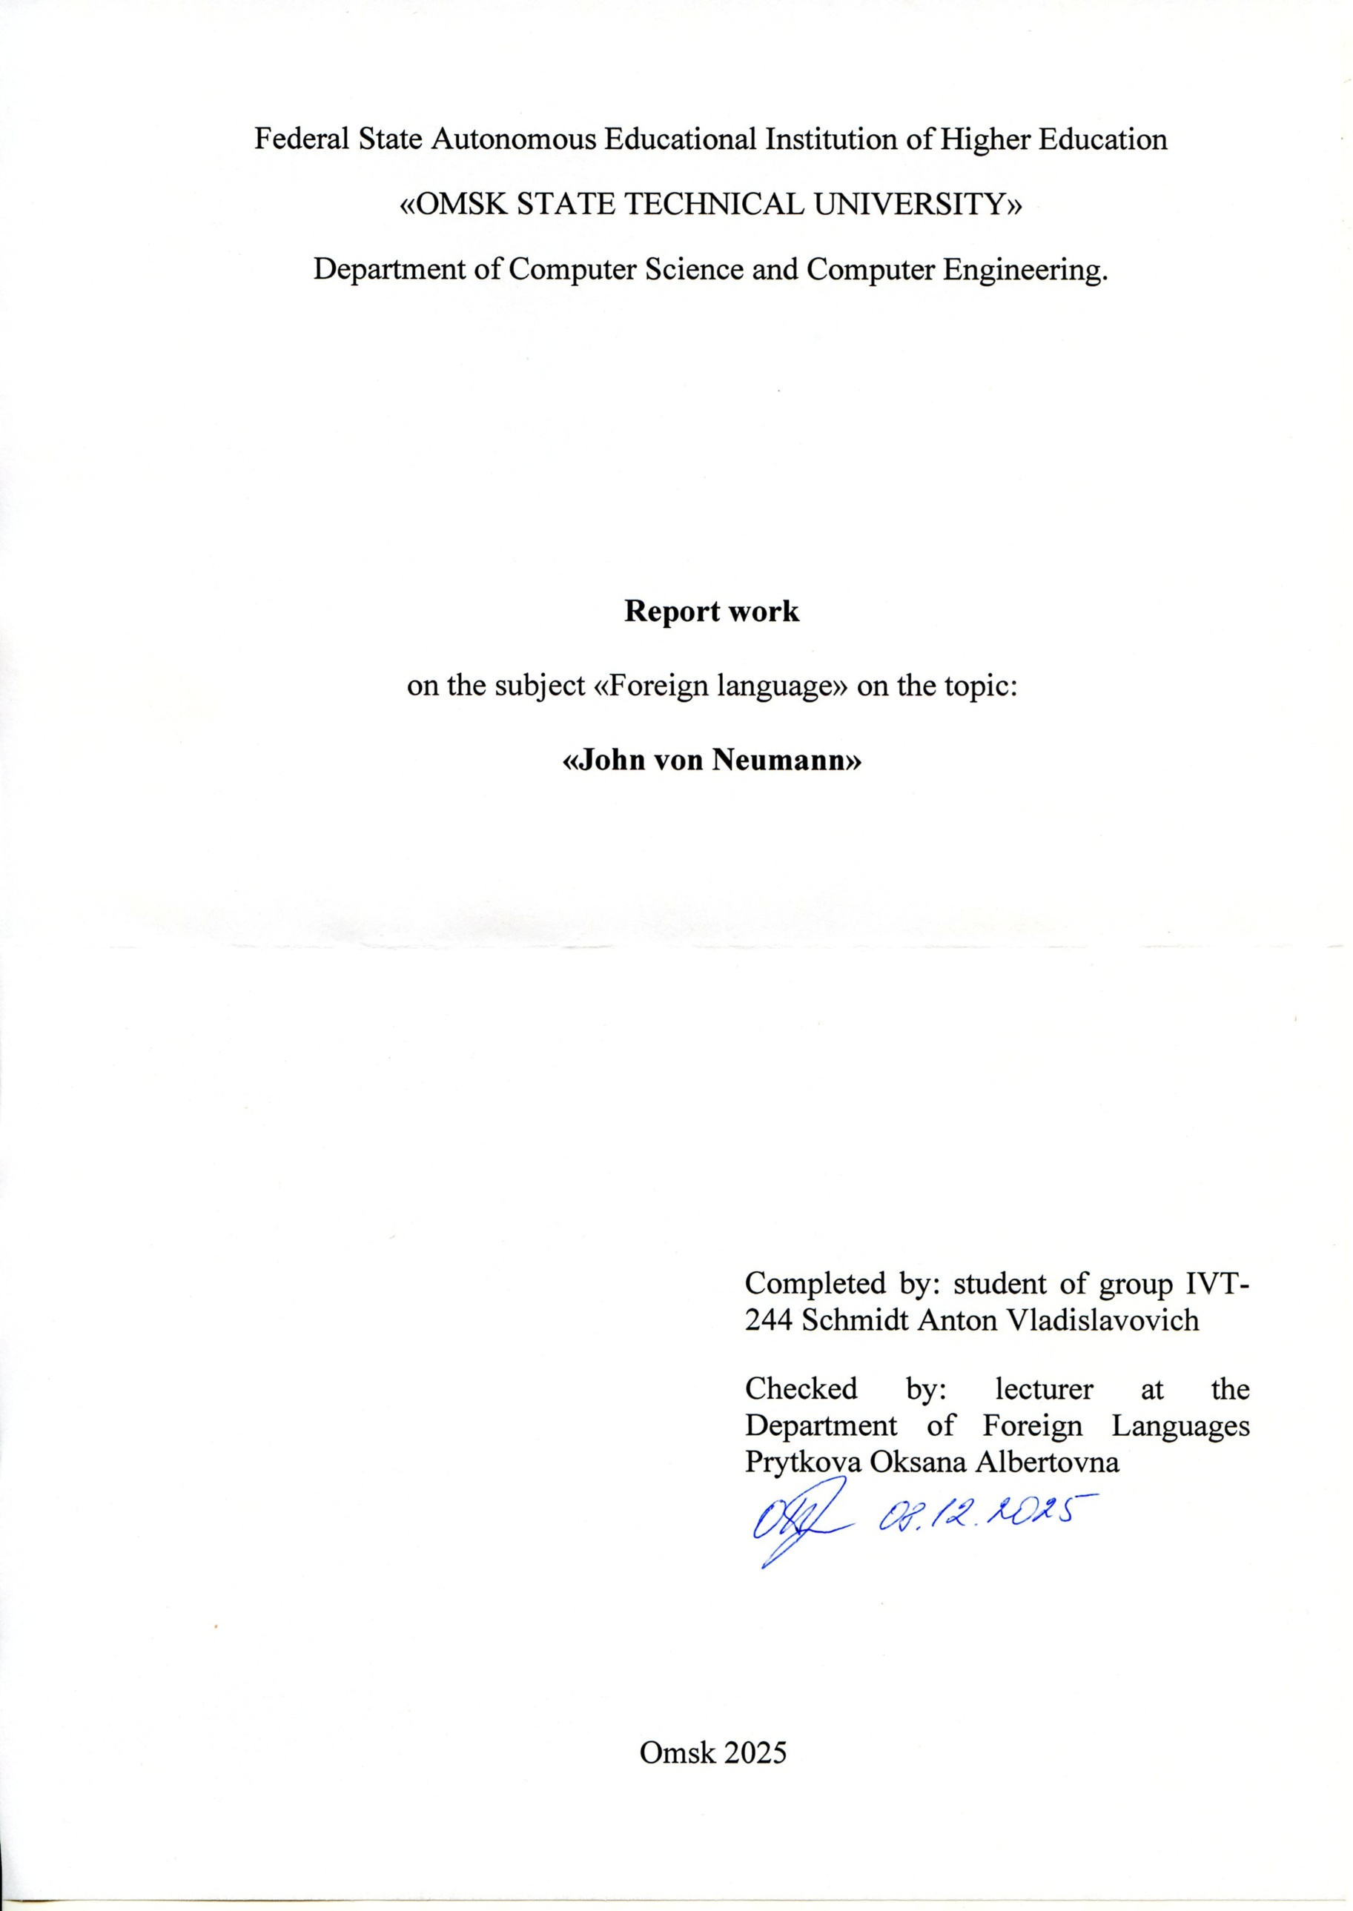
Federal State Autonomous Educational Institution of Higher Education
«OMSK STATE TECHNICAL UNIVERSITY»
Department of Computer Science and Computer Engineering.

Report work
on the subject «Foreign language» on the topic:
«John von Neumann»

Completed by: student of group IVT-244 Schmidt Anton Vladislavovich
Checked by: lecturer at the Department of Foreign Languages Prytkova Oksana Albertovna

Omsk 2025
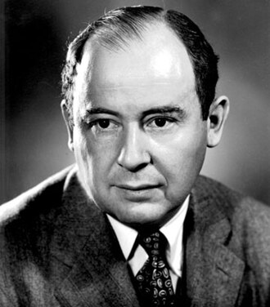
Early Life and Education (1903–1921)
John von Neumann was born on December 28, 1903, in Budapest. Raised in an educated and prosperous family, he demonstrated exceptional intellectual ability from early childhood. He mastered mental arithmetic, foreign languages, and advanced mathematics long before entering secondary school.
At the Lutheran Gymnasium he received rigorous scientific training and produced his first mathematical publication before graduation.
Academic Development and Early Work (1921–1929)
Von Neumann studied mathematics at the University of Budapest while simultaneously completing a chemical engineering degree at ETH Zurich. This dual path required exceptional discipline, but he excelled in both fields.
During the 1920s he made influential contributions to set theory, logic, algebra, and the early formulation of Hilbert spaces. By his mid-twenties he was recognized as one of Europe’s most promising young mathematicians.
Mathematics, Physics, and Game Theory (1929–1940)
In 1929 he joined the Institute for Advanced Study in Princeton, becoming one of its first permanent faculty members. His work from this period had lasting impact on both mathematics and quantum physics.
His 1932 book Mathematical Foundations of Quantum Mechanics established the operator-based formalism of quantum theory. He also collaborated with Oskar Morgenstern to develop the framework of game theory, introducing mathematical tools for analyzing strategic behavior and decision-making.
War Work and the Birth of Modern Computing (1940–1950)
With World War II, von Neumann applied his mathematical expertise to wartime research. He contributed to ballistics analysis, shock-wave modeling, and played a significant role in the Manhattan Project, particularly in refining calculations related to nuclear implosion.
These efforts led him directly to automated computation. Seeing the limitations of manual calculation, he helped shape the concept of the stored-program electronic computer. His 1945 First Draft of a Report on the EDVAC described an architecture with a central processor, memory, and instruction storage—now known as the von Neumann architecture.
Advances in Computing and Scientific Research (1950–1957)
At Princeton he directed the development of the IAS machine, one of the earliest high-speed general-purpose computers. Its design became the blueprint for later machines worldwide.
He also pioneered numerical weather prediction and explored theories of cellular automata and self-reproducing systems. His ideas foreshadowed modern fields such as distributed computing, artificial life, and complex systems modeling.
Legacy
Von Neumann’s contributions transformed mathematics, physics, economics, and computer science. His insights into stored-program architecture underpin nearly all modern computing systems, while his theoretical work continues to influence scientific disciplines across the spectrum.
He died on February 8, 1957, leaving an unparalleled legacy in the intellectual history of the 20th century.

